**NATIONAL UNIVERSITY OF COMPUTER AND EMERGING SCIENCES**

**CL307 COMPUTER NETWORKS LAB**

**LAB 07 – SMTP & FTP**



**OBJECTIVE: To understand and implement Simple Mail Transfer Protocol (SMTP) and File Transfer Protocol (FTP) in Cisco Packet Tracer.**

**SMTP:**

Simple Mail Transfer Protocol (SMTP) is an Internet standard for electronic mail (email) transmission. First defined by RFC 821 in 1982, it was last updated in 2008 with Extended SMTP additions by RFC 5321, which is the protocol in widespread use today. Although electronic mail servers and other mail transfer agents use SMTP to send and receive mail messages, user-level client mail applications typically use SMTP only for sending messages to a mail server for relaying. For retrieving messages, client applications usually use either IMAP or POP3.

SMTP communication between mail servers uses port 25. Mail clients on the other hand, often submit the outgoing emails to a mail server on port 587. Despite being deprecated, mail providers sometimes still permit the use of nonstandard port 465 for this purpose.

TOPOLOGY:

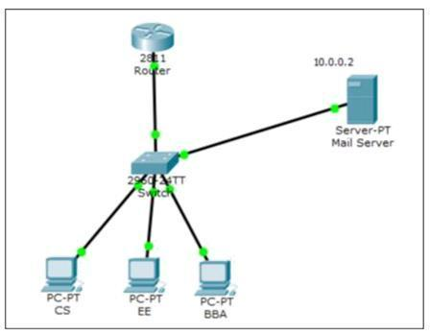

**Objectives: Configure and Verify Email Services**

Click on Mail server 🡪services 🡪EMAIL Enable SMTP & POP3 Service Set Domain Name:fast.com Add users

|  |  |
| --- | --- |
| Username | Password |
|  |  |
| cs | 123 |
|  |  |
| ee | 123 |
|  |  |
| bba | 123 |
|  |  |

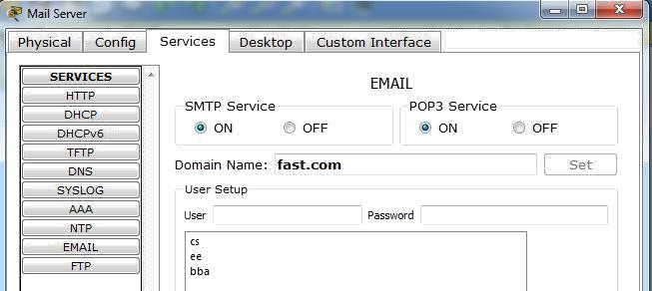

Now configuring user email account.

Go to pc **🡪**desktop **🡪**Email

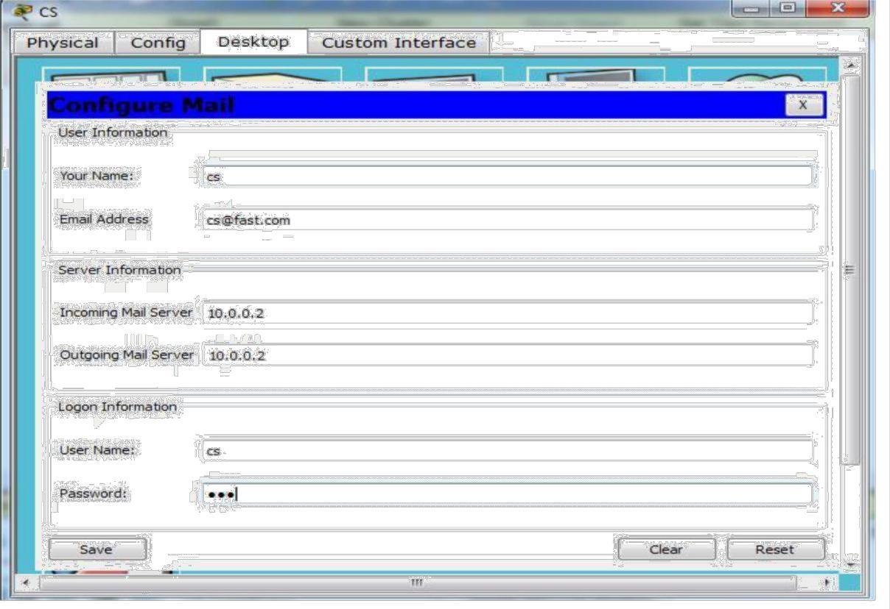

Click “Save” to save the configurations and do the same for EE and BBA.

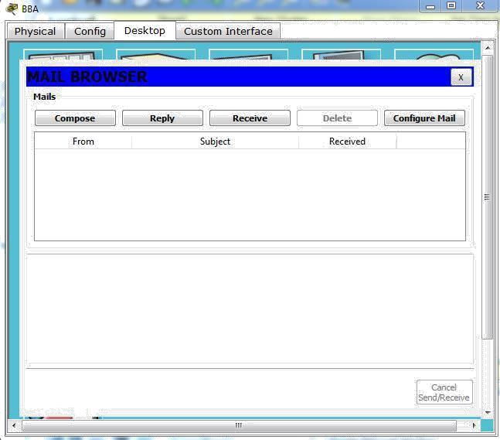

Now compose email **🡪** **cs@fast.com**

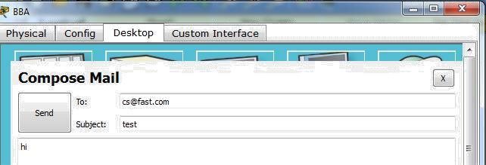

Click on “Send” to send the email.

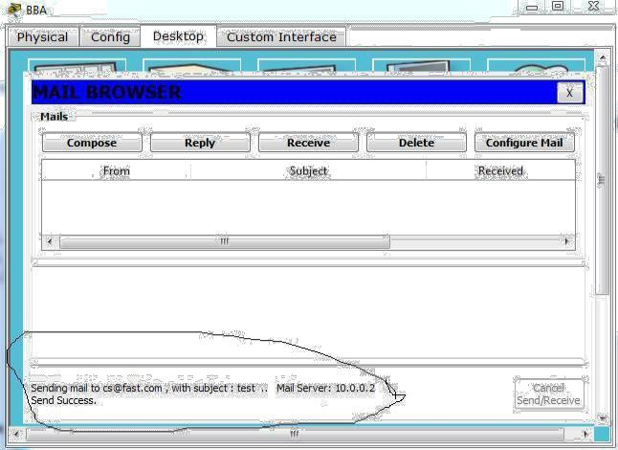

**SIMULATION**

Now to note the POP3 header format information go to simulation mode **🡪** edit filters and click on SMTP &POP3 check box then click on capture/forward button. Now see how mail server works.

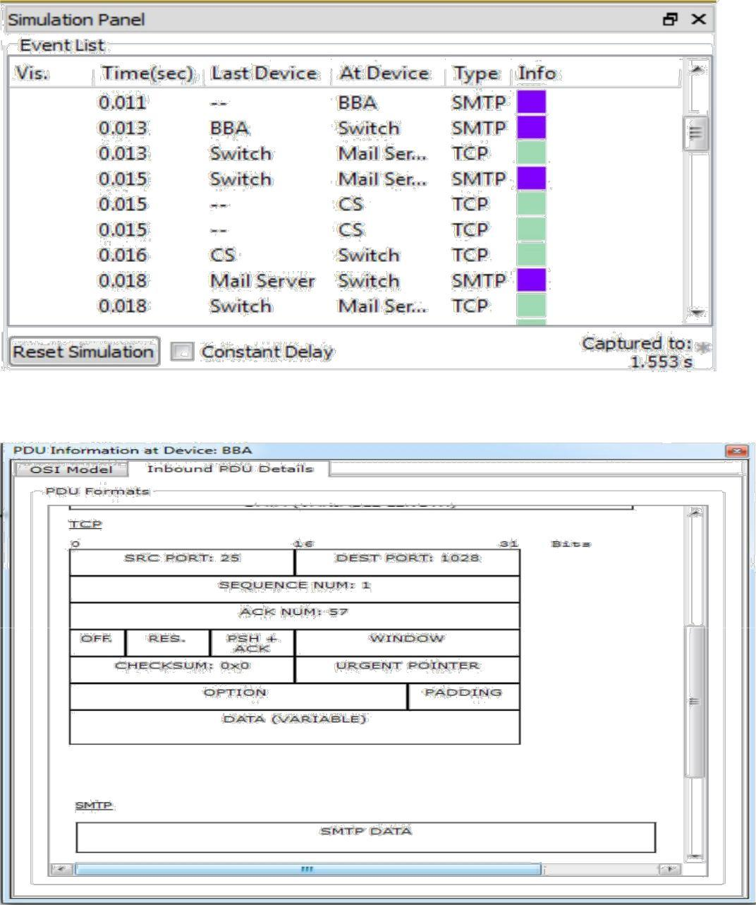

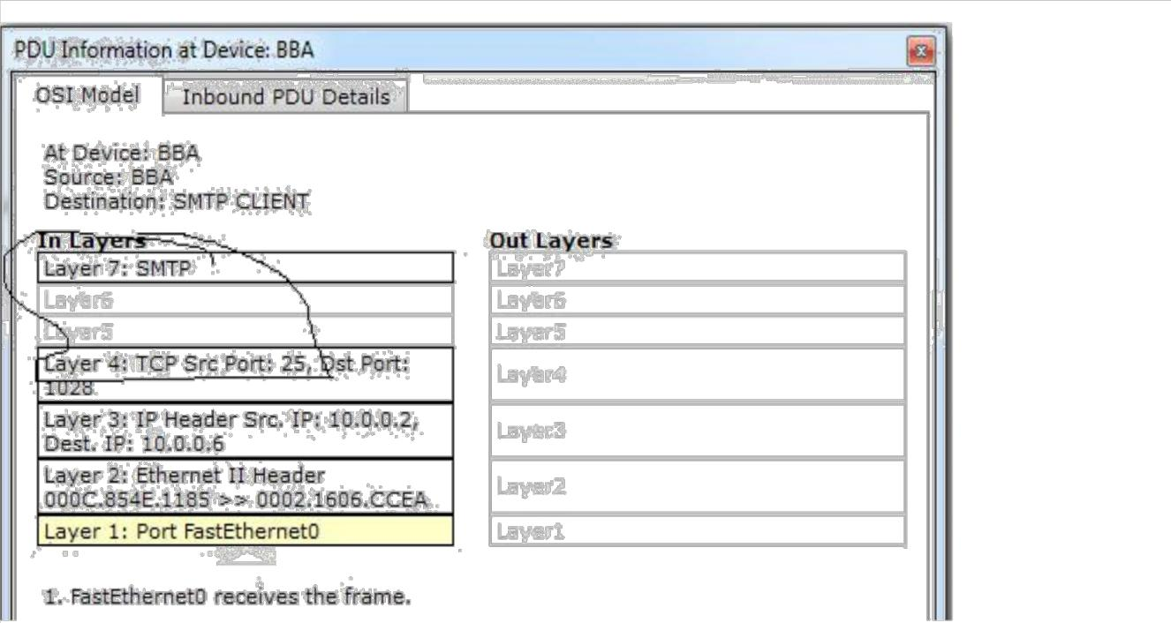

Now, go to CS record and click Receive:

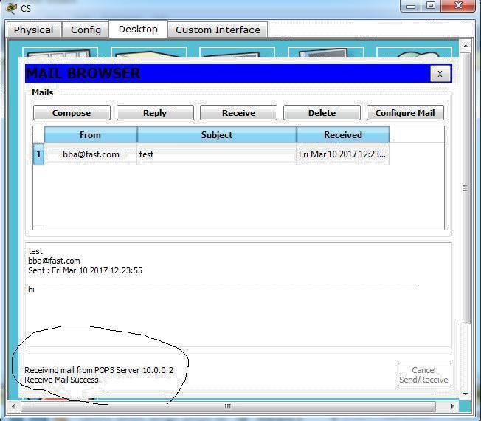

**NATIONAL UNIVERSITY OF COMPUTER AND EMERGING SCIENCES** Page 5

**File Transfer Protocol**

The File Transfer Protocol (FTP) is a standard network protocol used to transfer computer files between a client and server on a computer network. FTP is built on client-server model architecture and uses separate control and data connections between the client and the server.

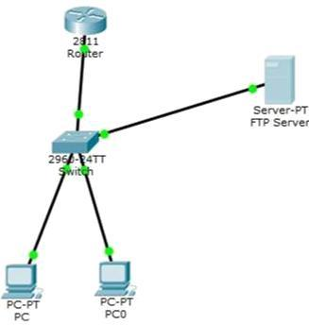

Objectives: In this activity, you will configure FTP services.

You will then use the FTP services to transfer files

between clients and the server.

**Part 1:** Configure FTP Services on Servers

**Part 2:** Upload a File to the FTP Server

**Part 3:** Download a File from the FTP Server

**Part 1: Configure FTP Services on Servers**

Step 1: Configure the FTP service on Server.

a. Click Server > Config tab > FTP.

b. Click On to enable FTP service.

c. In User Setup, create the following user accounts. Click the + button to add the account:

|  |  |  |
| --- | --- | --- |
| Username | Password | Permissions |
|  |  |  |
| fast | 123 | limited to Read, write and List |
|  |  |  |

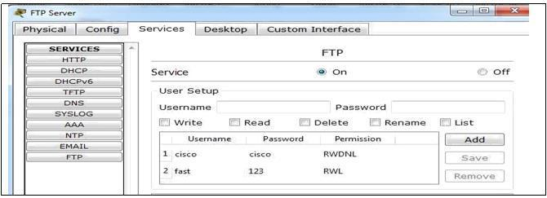

**NATIONAL UNIVERSITY OF COMPUTER AND EMERGING SCIENCES** Page 6

Now go to PC 🡪Desktop 🡪command prompt

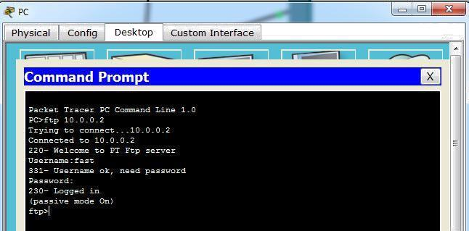

**Part 2: Upload a File to the FTP Server**

Now go to PC 🡪Desktop 🡪text editor 🡪create file named test.bin

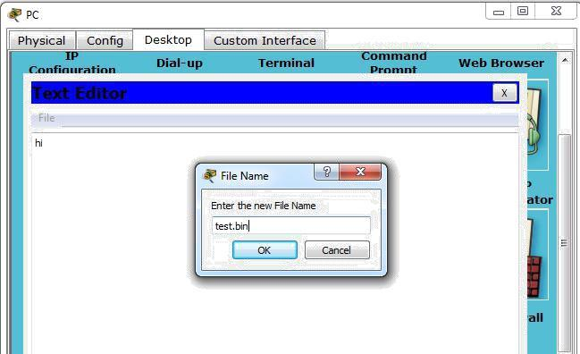

Now go to PC 🡪Desktop 🡪command prompt



**NATIONAL UNIVERSITY OF COMPUTER AND EMERGING SCIENCES** Page 7

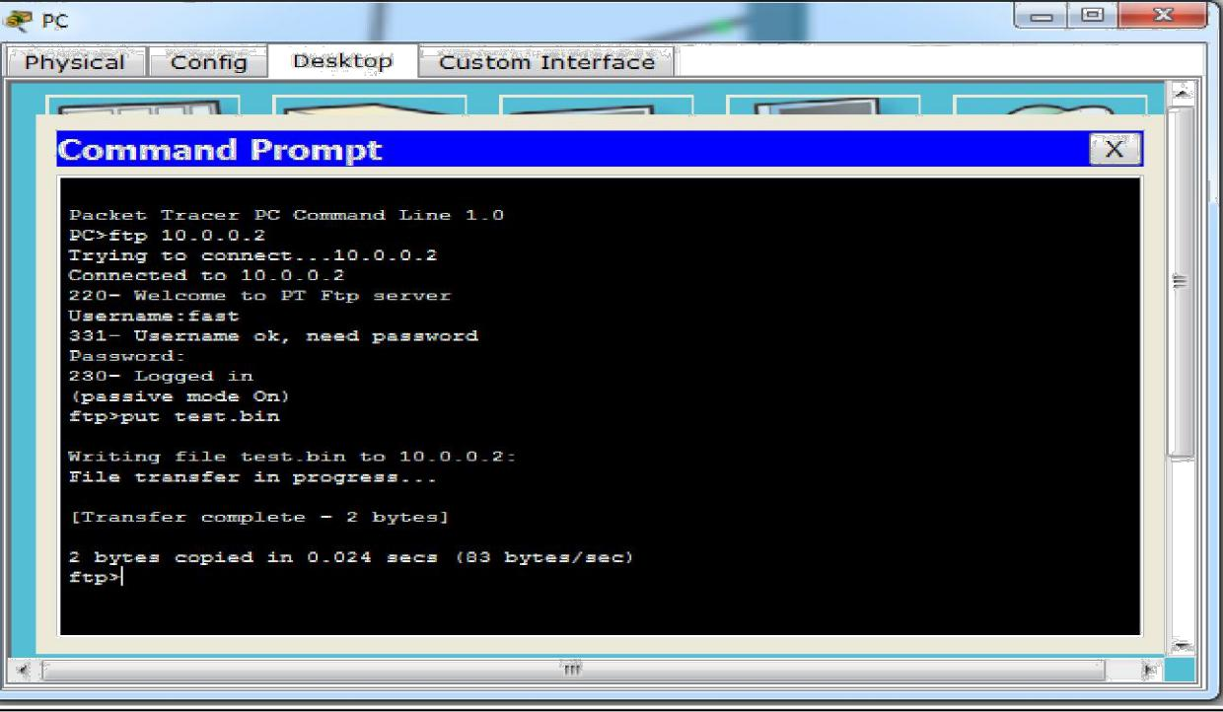

**Part 3: Download a File from the FTP Server**

Now go to PC 🡪Desktop 🡪command prompt

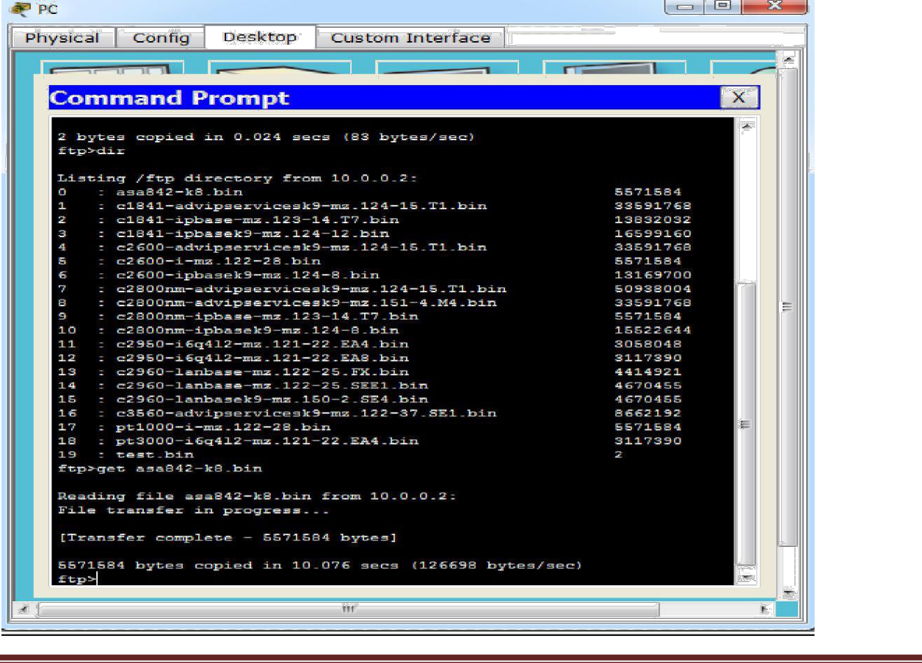

**NATIONAL UNIVERSITY OF COMPUTER AND EMERGING SCIENCES** Page 8

**SIMULATION:** Now click on PC and go to Desktop🡪command prompt. Now type ftp 10.0.0.2

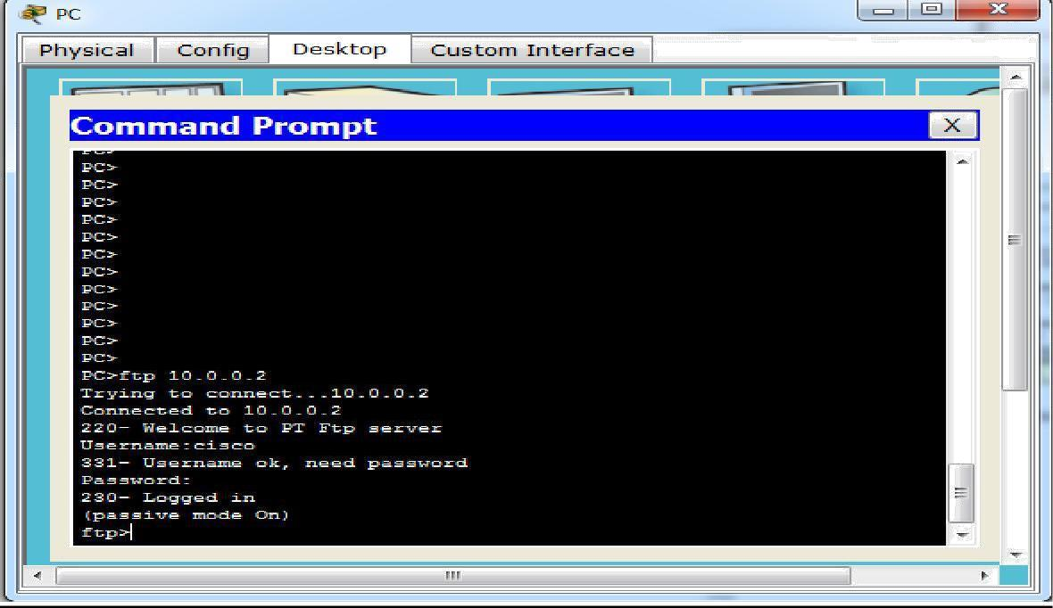

Now to note the FTP header format information go to simulation mode 🡪edit filters and click on FTP check box then click on capture/forward button.

How FTP server resolve the login request.

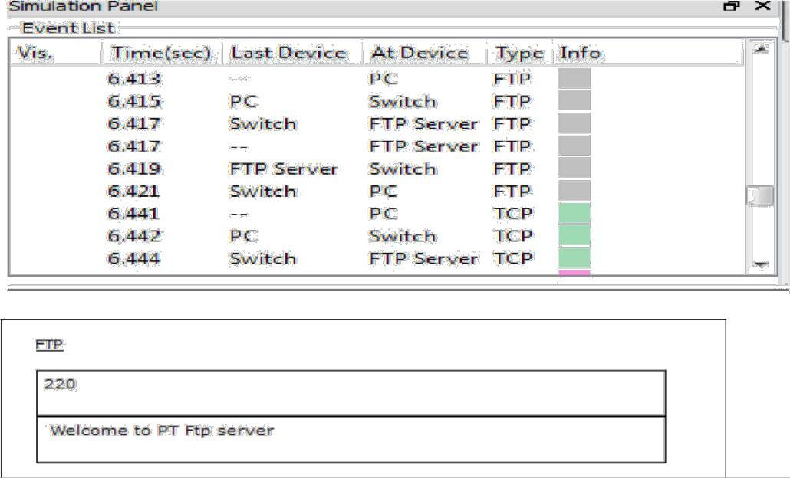

**NATIONAL UNIVERSITY OF COMPUTER AND EMERGING SCIENCES** Page 9

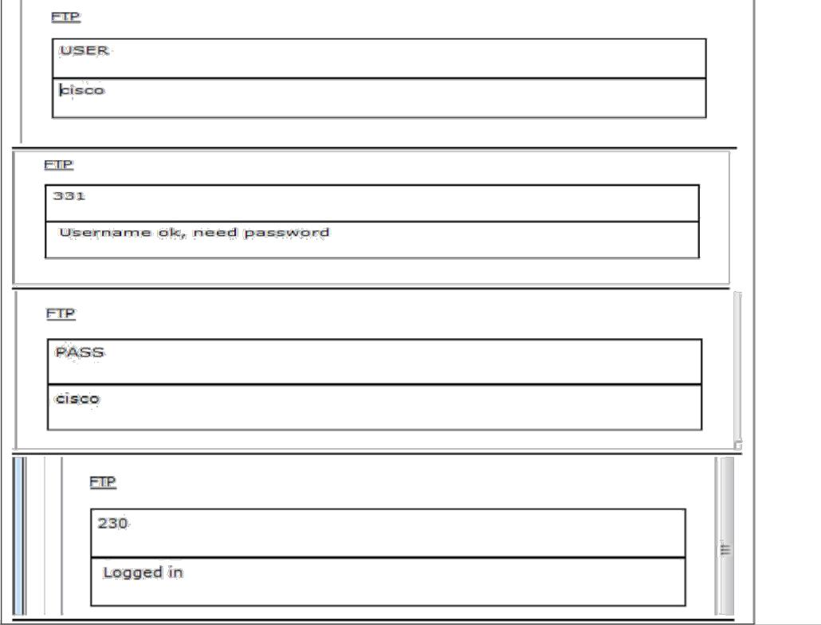

Now click on the FTP packet, you can note that the destination port is 21.

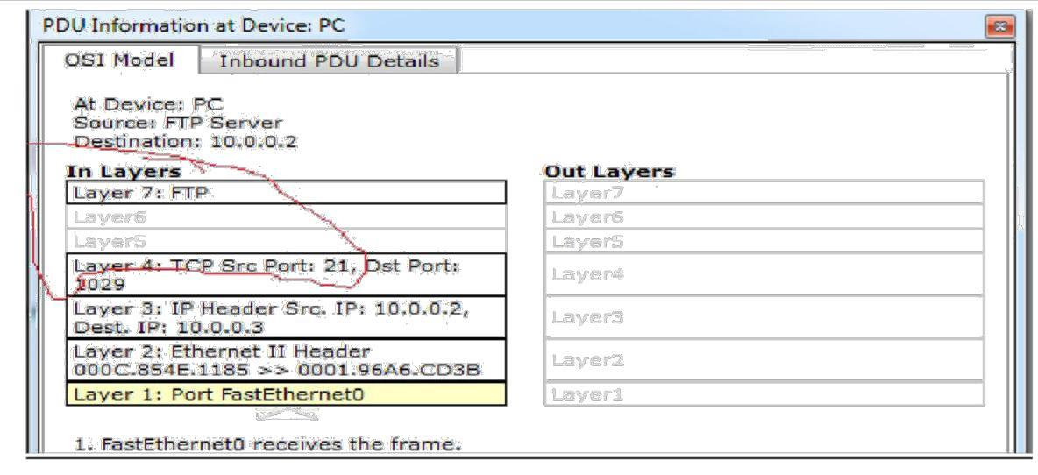

Now scroll the Outbound PDU Details, you can see the FTP PDU.



**NATIONAL UNIVERSITY OF COMPUTER AND EMERGING SCIENCES** Page 10

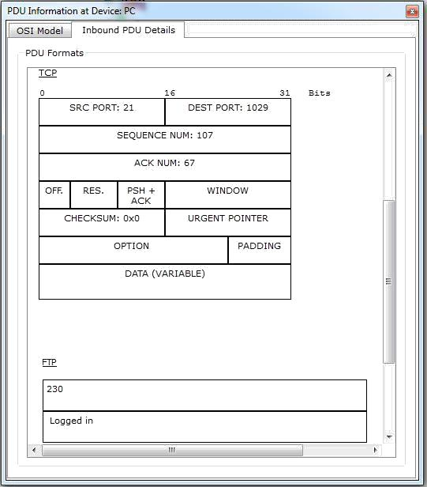

**NATIONAL UNIVERSITY OF COMPUTER AND EMERGING SCIENCES** Page 11